**13. Create an extended ACL to block specific applications, such as HTTP or FTP traffic. Test the ACL rules by attempting to access blocked services.**

**Steps Followed:**

* PC, Router, Server setup.
* IP addresses assigned.
* Server HTTP, FTP enabled.
* Router interface IPs set.
* ACL 101 created.
* ACL denies PC to Server: HTTP, FTP.
* ACL permits all other traffic.
* ACL applied to Router interface.
* HTTP, FTP access failed.

**Setting Up:**

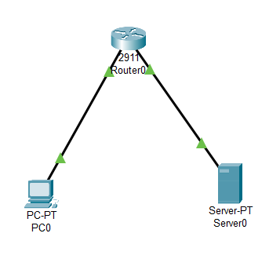

**ACL Configuration in router:**

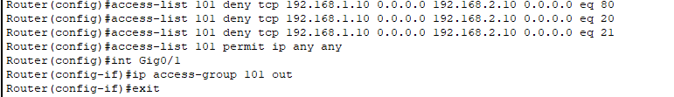

**HTTP request gets time out:**

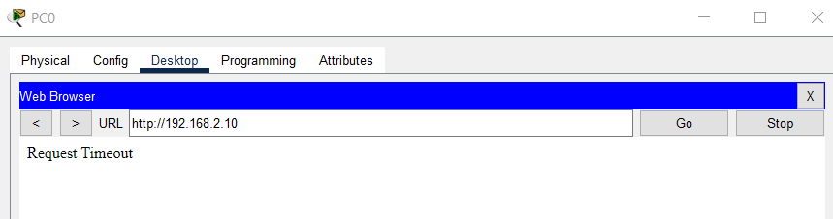

**FTP request:**

